**“Customer Purchase Analytics for E-commerce Platform”**

**Project Report  
Submitted by**

**Jenifer B**

**BADM-WD-T-B3**

**Project Overview:**

The Customer Purchase Analytics project aims to provide an in-depth analysis of customer purchasing behaviour on an e-commerce platform. By leveraging various datasets, the project seeks to uncover patterns in customer purchases, identify high-value products, and evaluate customer retention strategies. The insights gained from this analysis will inform marketing initiatives, aid in customer

**Key Milestones and Activities:**

1. Data Cleaning and Preprocessing

- Conducted data validation to ensure the accuracy and consistency of the datasets.

- Handled missing values and outliers through various imputation techniques and filtering methods.

- Standardized data formats to ensure uniformity across various data points (e.g., date formats, currency conversion).

2. Aggregation and Summary Statistics

- Generated summary statistics to quantify key metrics such as total sales, average transaction value, and customer count.

- Aggregate purchases by categories to identify trends and anomalies.

3. Data Joins and Merging

- Merged multiple datasets including customer profiles, transaction records, and product inventory to view customer behaviours and performance comprehensively.

- Ensured the integrity of the data through effective join techniques (inner join, outer join, etc.).

4. Window Functions and Advanced SQL Queries

- Utilized window functions to conduct operations over specified ranges of data, providing deeper insights into customer behaviours over time.

- Developed complex SQL queries to extract nuanced insights and facilitate advanced trend analyses.

5. Percentile Calculations and Ranking

- Computed percentiles to evaluate the distribution of purchase values across different customer segments and product categories.

- Ranked products and customers based on key performance metrics (e.g., frequency of purchases, average spend) to identify top performers.

6. Date Analysis and Time Series Analysis

- Conducted time series analysis to examine purchasing trends over time, identifying seasonal patterns and peak purchasing periods.

- Evaluated customer behaviour changes during promotional events and holiday seasons.

7. Advanced Data Visualization in Power BI

- Developed interactive dashboards in Power BI to visualize key metrics, making it easier for stakeholders to derive actionable insights.

- Implemented visual elements such as charts, graphs, and maps to effectively convey findings.

8. Business Insights Generation for E-commerce Strategy

- Synthesized analysis results to generate actionable business insights.

- Provided recommendations for targeted marketing strategies, customer segmentation, and inventory management based on the findings.

**Data Analytics Tasks:**

**#A. Basic Aggregation:**

1. **Find the total number of purchases per product per year and list down the top-selling products every year**

Select * from products_dataset;

Select * from purchase_history_dataset;

Select * from purchase_history_dataset where extract(year from purchase_date)=2023;

SELECT

YEAR(purchase_date) AS purchase_year,

product_id,

SUM(quantity) AS total_amount

FROM

purchase_history_dataset

GROUP BY

YEAR(purchase_date),

product_id

ORDER BY

purchase_year DESC,

total_amount DESC;

1. **Calculate the average quantity purchased per product and list down the top 5 products with high average quantity purchased**

SELECT

product_id,

AVG(quantity) AS avg_quantity

FROM

purchase_history_dataset

GROUP BY

product_id

ORDER BY

avg_quantity DESC

LIMIT 5;

**#B. Join Operations:**

1. **Join purchase history with products dataset to get the product name for each purchase.**

SELECT

purchase_history_dataset.purchase_id,

purchase_history_dataset.product_id,

purchase_history_dataset.purchase_date,

purchase_history_dataset.quantity,

products_dataset.product_name

FROM

purchase_history_dataset

JOIN

products_dataset

ON

purchase_history_dataset.product_id = products_dataset.product_id;

1. **Join purchase history with customer profile dataset to include customer information for each purchase and list the top 5 customers with high purchases**

SELECT

customer_profile_dataset.customer_id,

customer_profile_dataset.first_name,

customer_profile_dataset.email,

SUM(purchase_history_dataset.quantity) AS total_purchases

FROM

purchase_history_dataset

JOIN

customer_profile_dataset

ON

purchase_history_dataset.customer_id = customer_profile_dataset.customer_id

GROUP BY

customer_profile_dataset.customer_id, customer_profile_dataset.first_name, customer_profile_dataset.email

ORDER BY

total_purchases DESC

LIMIT 5;

**#C. Window Functions:**

1. **Find the cumulative sum of purchases for each product category over year.**

SELECT

YEAR(purchase_history_dataset.purchase_date) AS purchase_year,

products_dataset.category,

SUM(purchase_history_dataset.quantity) AS total_purchases,

SUM(SUM(purchase_history_dataset.quantity)) OVER (PARTITION BY products_dataset.category ORDER BY YEAR(purchase_history_dataset.purchase_date)) AS cumulative_purchases

FROM

purchase_history_dataset

JOIN

products_dataset ON products_dataset.product_id = products_dataset.product_id

GROUP BY

purchase_year, products_dataset.category

ORDER BY

purchase_year, products_dataset.category;

**#D. Rank and Dense Rank:**

1. **Rank customers based on their total expenditure.**

SELECT

customer_profile_dataset.customer_id,

customer_profile_dataset.first_name,

customer_profile_dataset.email,

SUM(purchase_history_dataset.quantity * purchase_history_dataset.total_amount) AS total_expenditure,

RANK() OVER (ORDER BY SUM(purchase_history_dataset.quantity * purchase_history_dataset.total_amount) DESC) AS expenditure_rank

FROM

purchase_history_dataset

JOIN

customer_profile_dataset ON purchase_history_dataset.customer_id = customer_profile_dataset.customer_id

GROUP BY

customer_profile_dataset.customer_id, customer_profile_dataset.first_name, customer_profile_dataset.email

ORDER BY

expenditure_rank;

1. **Identify the top 10 customers by purchase frequency using DENSE_RANK().**

SELECT

customer_profile_dataset.customer_id,

customer_profile_dataset.first_name,

COUNT(purchase_history_dataset.purchase_id) AS purchase_frequency,

DENSE_RANK() OVER (ORDER BY COUNT(purchase_history_dataset.purchase_id) DESC) AS Rank_no

FROM

purchase_history_dataset

JOIN

customer_profile_dataset ON purchase_history_dataset.customer_id = customer_profile_dataset.customer_id

GROUP BY

customer_profile_dataset.customer_id, customer_profile_dataset.first_name

ORDER BY

Rank_no

LIMIT 10;

**#E. Percentiles:**

1. **Calculate the 25th, 50th (median), and 75th percentiles of total purchase amounts for each customer segment.**

WITH total_purchases AS (

SELECT

customer_profile_dataset.customer_id,

purchase_history_dataset.total_amount

FROM

purchase_history_dataset

JOIN

customer_profile_dataset ON purchase_history_dataset.customer_id = customer_profile_dataset.customer_id

),

ranked_purchases AS (

SELECT

customer_id,

total_amount,

NTILE(100) OVER (PARTITION BY customer_id ORDER BY total_amount) AS percentile_rank

FROM

total_purchases

)

SELECT

customer_id,

MAX(CASE WHEN percentile_rank <= 25 THEN total_amount END) AS percentile_25,

MAX(CASE WHEN percentile_rank <= 50 THEN total_amount END) AS percentile_50,

MAX(CASE WHEN percentile_rank <= 75 THEN total_amount END) AS percentile_75

FROM

ranked_purchases

GROUP BY

customer_id;

**#F. Median Calculation:**

**1.Compute the median purchase amount per product category.**

WITH total_purchase_amounts AS (

SELECT

purchase_history_dataset.purchase_id,

purchase_history_dataset.product_id,

purchase_history_dataset.quantity * purchase_history_dataset.total_amount AS total_purchase_amount

FROM

purchase_history_dataset

),

ranked_purchase_amounts AS (

SELECT

t.total_purchase_amount,

products_dataset.category,

ROW_NUMBER() OVER (PARTITION BY products_dataset.category ORDER BY t.total_purchase_amount) AS row_num,

COUNT(*) OVER (PARTITION BY products_dataset.category) AS total_rows

FROM

total_purchase_amounts t

JOIN

products_dataset ON t.product_id = products_dataset.product_id

)

SELECT

category,

AVG(total_purchase_amount) AS median_purchase_amount

FROM

ranked_purchase_amounts

WHERE

row_num IN (FLOOR((total_rows + 1) / 2), CEIL((total_rows + 1) / 2))

GROUP BY

category;

**#G. Complex Aggregation:**

1. **Find the average, maximum, and minimum purchase value for each product type and customer age group.**

SELECT

products_dataset.category,

CASE

WHEN customer_profile_dataset.date_of_birth < 18 THEN 'Under 18'

WHEN customer_profile_dataset.date_of_birth BETWEEN 18 AND 34 THEN '18-34'

WHEN customer_profile_dataset.date_of_birth BETWEEN 35 AND 54 THEN '35-54'

WHEN customer_profile_dataset.date_of_birth BETWEEN 55 AND 74 THEN '55-74'

ELSE '75+'

END AS age_group,

AVG(purchase_history_dataset.quantity * purchase_history_dataset.total_amount) AS avg_purchase_value,

MAX(purchase_history_dataset.quantity * purchase_history_dataset.total_amount) AS max_purchase_value,

MIN(purchase_history_dataset.quantity * purchase_history_dataset.total_amount) AS min_purchase_value

FROM

purchase_history_dataset

JOIN

products_dataset ON purchase_history_dataset.product_id = products_dataset.product_id

JOIN

customer_profile_dataset ON purchase_history_dataset.customer_id = customer_profile_dataset.customer_id

GROUP BY

products_dataset.category,

CASE

WHEN customer_profile_dataset.date_of_birth < 18 THEN 'Under 18'

WHEN customer_profile_dataset.date_of_birth BETWEEN 18 AND 34 THEN '18-34'

WHEN customer_profile_dataset.date_of_birth BETWEEN 35 AND 54 THEN '35-54'

WHEN customer_profile_dataset.date_of_birth BETWEEN 55 AND 74 THEN '55-74'

ELSE '75+'

END

ORDER BY

products_dataset.category, age_group;

**#H. Grouping:**

1. **Group purchases by day of the week and find the average number of purchases made on each day.**

SELECT

DAYNAME(purchase_day) AS day_of_week,

COUNT(*) AS total_days,

SUM(daily_purchases) AS total_purchases,

AVG(daily_purchases) AS average_purchases

FROM (

SELECT

DATE(purchase_date) AS purchase_day,

COUNT(*) AS daily_purchases

FROM purchase_history_dataset

GROUP BY purchase_day

) AS daily_stats

GROUP BY day_of_week

ORDER BY FIELD(day_of_week, 'Sunday', 'Monday', 'Tuesday', 'Wednesday', 'Thursday', 'Friday', 'Saturday');

1. **Group customers by city and find the total number of purchases and total revenue generated.**

SELECT

customer_profile_dataset.city,

COUNT(purchase_history_dataset.purchase_id) AS total_purchases,

SUM(purchase_history_dataset.total_amount) AS total_revenue

FROM purchase_history_dataset

JOIN customer_profile_dataset ON purchase_history_dataset.customer_id = customer_profile_dataset.customer_id

GROUP BY customer_profile_dataset.city

ORDER BY total_revenue DESC;

**#I. Case Statement:**

1. **Classify customers as “High-Spending,” “Medium-Spending,” or “Low-Spending” based on their total purchase amounts (using percentiles in multiples of 33).**

WITH customer_totals AS (

SELECT

customer_id,

SUM(total_amount) AS total_spent

FROM purchase_history_dataset

GROUP BY customer_id

),

ranked_customers AS (

SELECT

customer_id,

total_spent,

NTILE(100) OVER (ORDER BY total_spent) AS percentile_rank

FROM customer_totals

)

SELECT

customer_id,

total_spent,

CASE

WHEN percentile_rank <= 33 THEN 'Low-Spending'

WHEN percentile_rank > 33 AND percentile_rank <= 66 THEN 'Medium-Spending'

ELSE 'High-Spending'

END AS spending_category

FROM ranked_customers;

**#J. Join with Condition:**

1. **Join purchase history with customer profile dataset where the customer’s age is above 30, and display their purchase details.**

SELECT

purchase_history_dataset.purchase_id,

purchase_history_dataset.purchase_date,

purchase_history_dataset.total_amount,

customer_profile_dataset.customer_id,

customer_profile_dataset.first_name,

customer_profile_dataset.date_of_birth,

customer_profile_dataset.city

FROM purchase_history_dataset

JOIN customer_profile_dataset ON purchase_history_dataset.customer_id = customer_profile_dataset.customer_id

WHERE customer_profile_dataset.date_of_birth > 30;

**#K. Top N Analysis:**

1. **Find the top 5 products contributing to the highest revenue.**

SELECT

products_dataset.product_id,

products_dataset.product_name,

SUM(purchase_history_dataset.quantity * purchase_history_dataset.total_amount) AS total_revenue

FROM

purchase_history_dataset

JOIN

products_dataset ON purchase_history_dataset.product_id = products_dataset.product_id

GROUP BY

products_dataset.product_id, products_dataset.product_name

ORDER BY

total_revenue DESC

LIMIT 5;

1. **Identify the top 3 cities with the most number of unique customers.**

SELECT

customer_profile_dataset.city,

COUNT(DISTINCT customer_profile_dataset.customer_id) AS unique_customers

FROM

customer_profile_dataset

GROUP BY

customer_profile_dataset.city

ORDER BY

unique_customers DESC

LIMIT 3;

**#L. Window Functions for Trend Analysis:**

1. **Create a 7-day moving average of total purchases per product and which customer had high 7 day MA**

WITH daily_product_sales AS (

SELECT

purchase_history_dataset.purchase_date,

purchase_history_dataset.product_id,

SUM(purchase_history_dataset.total_amount) AS total_purchase_amount

FROM

purchase_history_dataset

GROUP BY

purchase_history_dataset.purchase_date, purchase_history_dataset.product_id

),

product_sales_with_ma AS (

SELECT

d.purchase_date,

d.product_id,

d.total_purchase_amount,

AVG(d.total_purchase_amount) OVER (

PARTITION BY d.product_id

ORDER BY d.purchase_date

ROWS BETWEEN 6 PRECEDING AND CURRENT ROW

) AS seven_day_ma

FROM

daily_product_sales d

)

SELECT

p.product_id,

p.purchase_date,

p.seven_day_ma,

customer_profile_dataset.customer_id,

customer_profile_dataset.first_name,

customer_profile_dataset.last_name

FROM

product_sales_with_ma p

JOIN

purchase_history_dataset ON p.product_id = purchase_history_dataset.product_id AND p.purchase_date = purchase_history_dataset.purchase_date

JOIN

customer_profile_dataset ON purchase_history_dataset.customer_id = customer_profile_dataset.customer_id

ORDER BY

p.seven_day_ma DESC

LIMIT 1;

**#M. Nested Queries:**

1. **Find customers who have never purchased products from the top 5 most popular categories.**

WITH top_categories AS (

SELECT

products_dataset.category,

SUM(purchase_history_dataset.total_amount) AS total_revenue

FROM

purchase_history_dataset

JOIN

products_dataset ON purchase_history_dataset.product_id = products_dataset.product_id

GROUP BY

products_dataset.category

ORDER BY

total_revenue DESC

LIMIT 5

),

customers_in_top_categories AS (

SELECT DISTINCT

customer_profile_dataset.customer_id

FROM

purchase_history_dataset

JOIN

products_dataset ON purchase_history_dataset.product_id = products_dataset.product_id

JOIN

customer_profile_dataset ON purchase_history_dataset.customer_id = customer_profile_dataset.customer_id

WHERE

products_dataset.category IN (SELECT category FROM top_categories)

)

SELECT

customer_profile_dataset.customer_id,

customer_profile_dataset.first_name,

customer_profile_dataset.last_name

FROM

customer_profile_dataset

LEFT JOIN

customers_in_top_categories citc ON customer_profile_dataset.customer_id = citc.customer_id

WHERE

citc.customer_id IS NULL;

1. **Identify products purchased only once in the entire dataset.**

SELECT

products_dataset.product_id,

products_dataset.product_name,

COUNT(purchase_history_dataset.purchase_id) AS purchase_count

FROM

purchase_history_dataset

JOIN

products_dataset ON purchase_history_dataset.product_id = products_dataset.product_id

GROUP BY

products_dataset.product_id, products_dataset.product_name

HAVING

purchase_count = 1;

**#N. Date Analysis:**

1. **Identify the month with the highest total sales volume.**

SELECT

YEAR(purchase_history_dataset.purchase_date) AS purchase_year,

MONTH(purchase_history_dataset.purchase_date) AS purchase_month,

SUM(purchase_history_dataset.total_amount) AS total_sales_volume

FROM

purchase_history_dataset

GROUP BY

purchase_year, purchase_month

ORDER BY

total_sales_volume DESC

LIMIT 1;

1. **Calculate the year-over-year growth of total sales.**

WITH yearly_sales AS (

SELECT

YEAR(purchase_history_dataset.purchase_date) AS purchase_year,

SUM(purchase_history_dataset.total_amount) AS total_sales

FROM

purchase_history_dataset

GROUP BY

purchase_year

)

SELECT

current_year.purchase_year AS year,

current_year.total_sales AS total_sales_current_year,

previous_year.total_sales AS total_sales_previous_year,

IFNULL(((current_year.total_sales - previous_year.total_sales) / previous_year.total_sales) * 100, 0) AS yoy_growth_percentage

FROM

yearly_sales current_year

LEFT JOIN

yearly_sales previous_year ON current_year.purchase_year = previous_year.purchase_year + 1

ORDER BY

current_year.purchase_year DESC;

**#O. Join with Aggregation:**

1. **Join all three datasets to find the total revenue per product per customer.**

SELECT

customer_profile_dataset.customer_id,

customer_profile_dataset.first_name,

customer_profile_dataset.last_name,

products_dataset.product_id,

products_dataset.product_name,

SUM(purchase_history_dataset.quantity * purchase_history_dataset.total_amount) AS total_revenue_per_product_per_customer

FROM

purchase_history_dataset

JOIN

products_dataset ON purchase_history_dataset.product_id = products_dataset.product_id

JOIN

customer_profile_dataset ON purchase_history_dataset.customer_id = customer_profile_dataset.customer_id

GROUP BY

customer_profile_dataset.customer_id, customer_profile_dataset.first_name, customer_profile_dataset.last_name, products_dataset.product_id, products_dataset.product_name

ORDER BY

customer_profile_dataset.customer_id, products_dataset.product_id;

**#P. Customer Retention:**

1. **Find the percentage of repeat customers in the dataset.**

WITH customer_purchase_count AS (

SELECT

customer_id,

COUNT(DISTINCT purchase_id) AS purchase_count

FROM

purchase_history_dataset

GROUP BY

customer_id

)

SELECT

(COUNT(CASE WHEN purchase_count > 1 THEN 1 END) / COUNT(*)) * 100 AS repeat_customers_percentage

FROM

customer_purchase_count;

1. **Calculate the average number of days between purchases for repeat customers.**

WITH customer_purchases AS (

SELECT

customer_id,

purchase_date,

ROW_NUMBER() OVER (PARTITION BY customer_id ORDER BY purchase_date) AS purchase_rank

FROM

purchase_history_dataset

),

purchase_differences AS (

SELECT

cp1.customer_id,

DATEDIFF(cp1.purchase_date, cp2.purchase_date) AS days_between_purchases

FROM

customer_purchases cp1

JOIN

customer_purchases cp2 ON cp1.customer_id = cp2.customer_id

WHERE

cp1.purchase_rank > cp2.purchase_rank

)

SELECT

AVG(days_between_purchases) AS avg_days_between_purchases

FROM

purchase_differences;

**#Q. Time Series Analysis:**

1. **Find the products with the highest growth in purchase frequency over time (average purchase YOY).**

WITH product_yearly_sales AS (

SELECT

products_dataset.product_id,

YEAR(purchase_history_dataset.purchase_date) AS purchase_year,

COUNT(purchase_history_dataset.purchase_id) AS purchase_count

FROM

purchase_history_dataset

JOIN

products_dataset ON purchase_history_dataset.product_id = products_dataset.product_id

GROUP BY

products_dataset.product_id, purchase_year

),

product_growth AS (

SELECT

current_year.product_id,

current_year.purchase_year,

current_year.purchase_count AS current_year_sales,

previous_year.purchase_count AS previous_year_sales,

IFNULL(((current_year.purchase_count - previous_year.purchase_count) / previous_year.purchase_count) * 100, 0) AS yoy_growth_percentage

FROM

product_yearly_sales current_year

LEFT JOIN

product_yearly_sales previous_year

ON current_year.product_id = previous_year.product_id

AND current_year.purchase_year = previous_year.purchase_year + 1

)

SELECT

product_id,

AVG(yoy_growth_percentage) AS avg_yoy_growth

FROM

product_growth

GROUP BY

product_id

ORDER BY

avg_yoy_growth DESC

LIMIT 5;

**#R. Subqueries:**

1. **Identify customers whose total expenditure is above the average expenditure of all customers.**

WITH customer_expenditures AS (

SELECT

customer_id,

SUM(total_amount) AS total_expenditure

FROM

purchase_history_dataset

GROUP BY

customer_id

),

average_expenditure AS (

SELECT

AVG(total_expenditure) AS avg_expenditure

FROM

customer_expenditures

)

SELECT

ce.customer_id,

ce.total_expenditure

FROM

customer_expenditures ce

JOIN

average_expenditure ae ON ce.total_expenditure > ae.avg_expenditure;

1. **Find products with a purchase amount higher than the average purchase amount across all products.**

WITH product_purchase_amounts AS (

SELECT

products_dataset.product_id,

products_dataset.product_name,

SUM(purchase_history_dataset.quantity * purchase_history_dataset.total_amount) AS total_purchase_amount

FROM

purchase_history_dataset

JOIN

products_dataset ON purchase_history_dataset.product_id = products_dataset.product_id

GROUP BY

products_dataset.product_id, products_dataset.product_name

),

average_purchase_amount AS (

SELECT

AVG(total_purchase_amount) AS avg_purchase_amount

FROM

product_purchase_amounts

)

SELECT

p.product_id,

p.product_name,

p.total_purchase_amount

FROM

product_purchase_amounts p

JOIN

average_purchase_amount a ON p.total_purchase_amount > a.avg_purchase_amount;

**#S. Correlated Subqueries:**

1. **Find the purchase dates where a customer made a purchase larger than their average purchase amount.**

WITH customer_average_purchase AS (

SELECT

customer_id,

AVG(total_amount) AS avg_purchase_amount

FROM

purchase_history_dataset

GROUP BY

customer_id

)

SELECT

purchase_history_dataset.customer_id,

purchase_history_dataset.purchase_date,

purchase_history_dataset.total_amount

FROM

purchase_history_dataset

JOIN

customer_average_purchase cap ON purchase_history_dataset.customer_id = cap.customer_id

WHERE

purchase_history_dataset.total_amount > cap.avg_purchase_amount;

1. **List all products that were purchased more frequently than the average frequency of products in their category.**

WITH product_purchase_frequency AS (

SELECT

p.product_id,

p.product_name,

p.category,

COUNT(pu.purchase_id) AS purchase_frequency

FROM

purchase_history_dataset pu

JOIN

products_dataset p ON pu.product_id = p.product_id

GROUP BY

p.product_id, p.product_name, p.category

),

category_average_frequency AS (

SELECT

category,

AVG(purchase_frequency) AS avg_frequency

FROM

product_purchase_frequency

GROUP BY

category

)

SELECT

ppf.product_id,

ppf.product_name,

ppf.category,

ppf.purchase_frequency

FROM

product_purchase_frequency ppf

JOIN

category_average_frequency caf ON ppf.category = caf.category

WHERE

ppf.purchase_frequency > caf.avg_frequency;

**#T. Date Functions:**

1. **Extract the day, month, and year from the purchase date, and group total purchases by month across all years**

SELECT

YEAR(purchase_date) AS purchase_year,

MONTH(purchase_date) AS purchase_month,

COUNT(*) AS total_purchases

FROM

purchase_history_dataset

GROUP BY

purchase_year, purchase_month

ORDER BY

purchase_year, purchase_month;

**U. Visualization in Power BI:**

1. Create a bar chart showing the total purchases per product category.

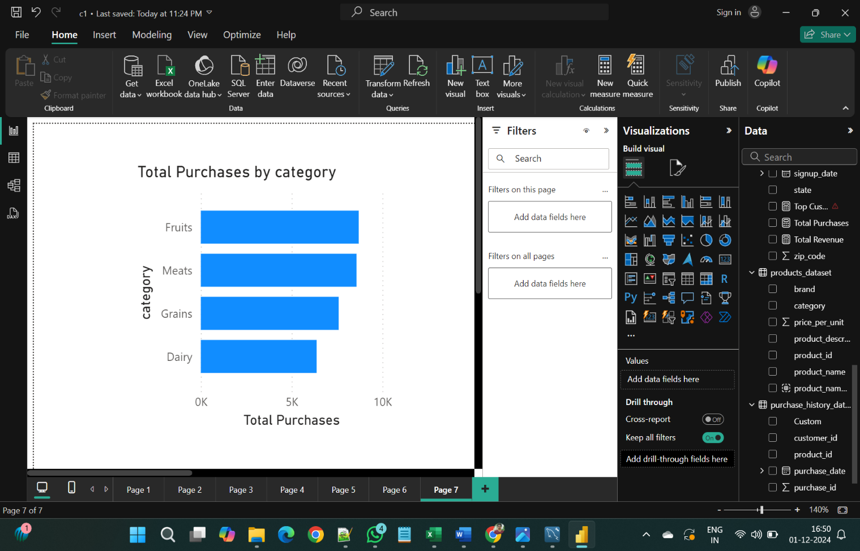

1. Build a line chart showing the trend of total sales over time.

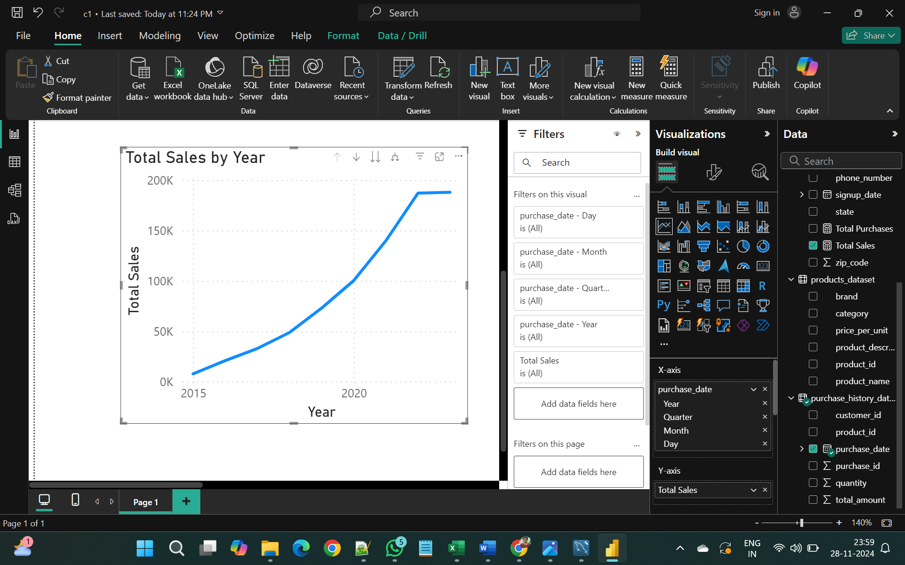

1. Design a pie chart representing the distribution of customers by city.

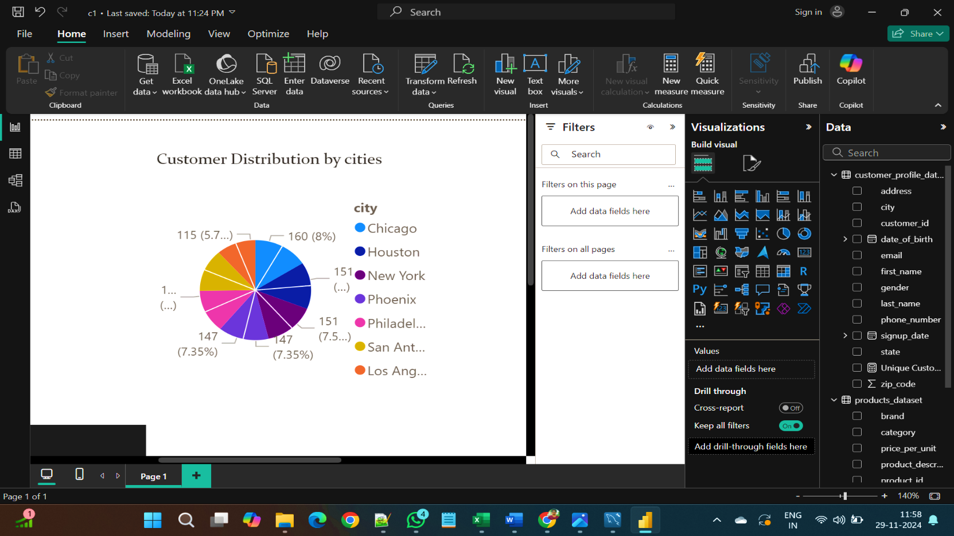

1. Implement a heat map displaying the correlation between customer age and total expenditure.

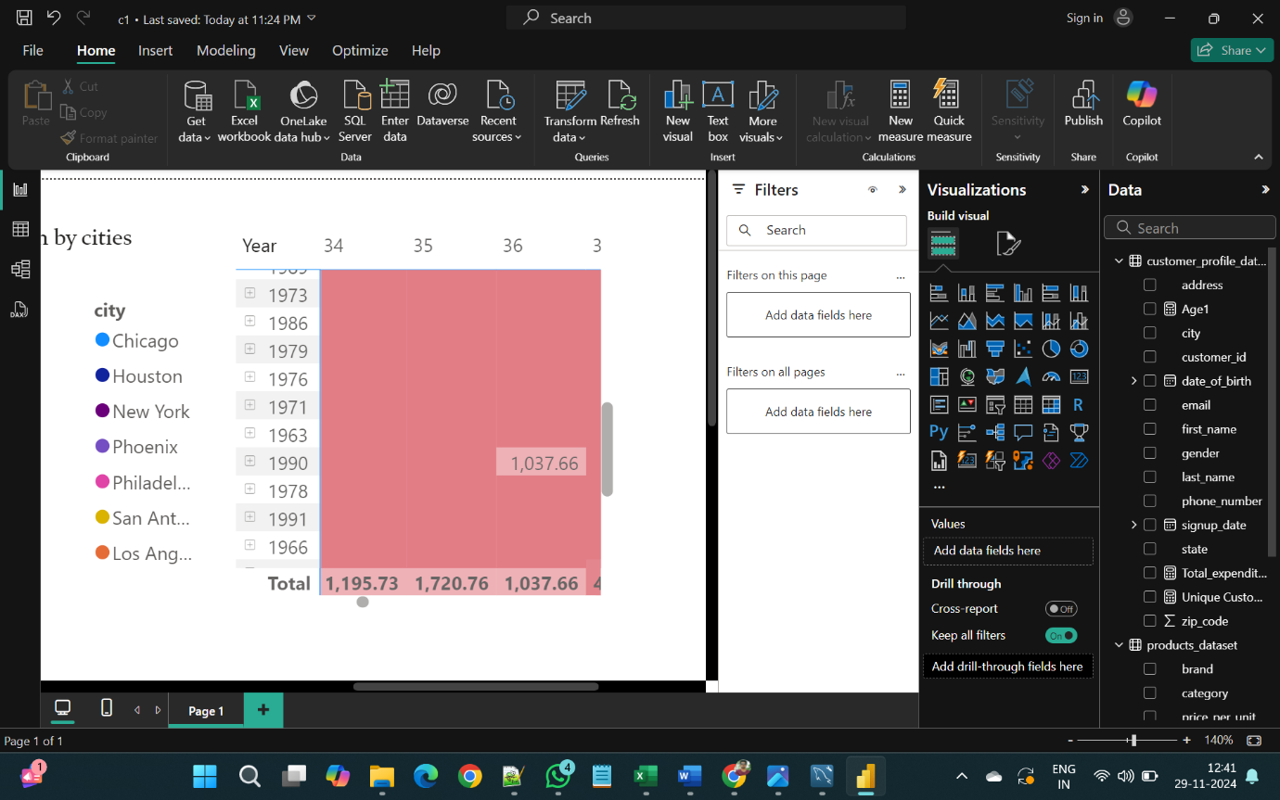

1. Use slicers to filter data by product category, customer age group, and city.

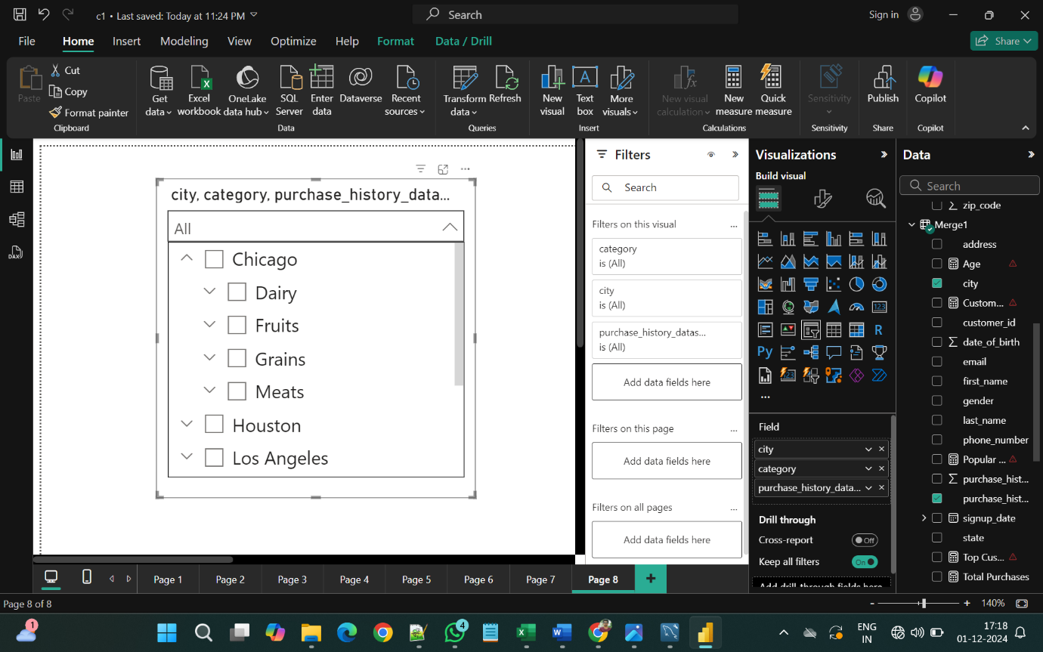

**V. Advanced Visuals:**

1. Implement a scatter plot to visualize the relationship between customer age and average purchase value.

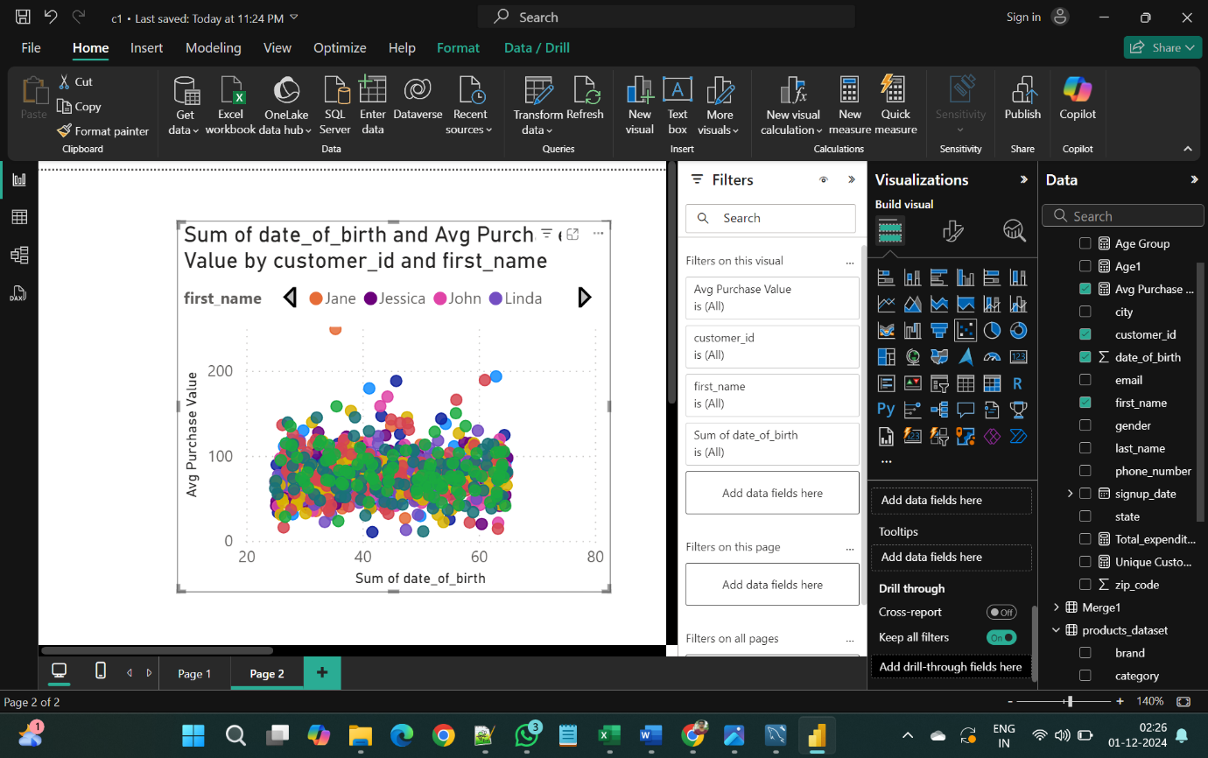

**W. Power BI Dashboard:**

1. Combine multiple visualizations into a dashboard summarizing key performance indicators like total revenue, top customers, and popular products.

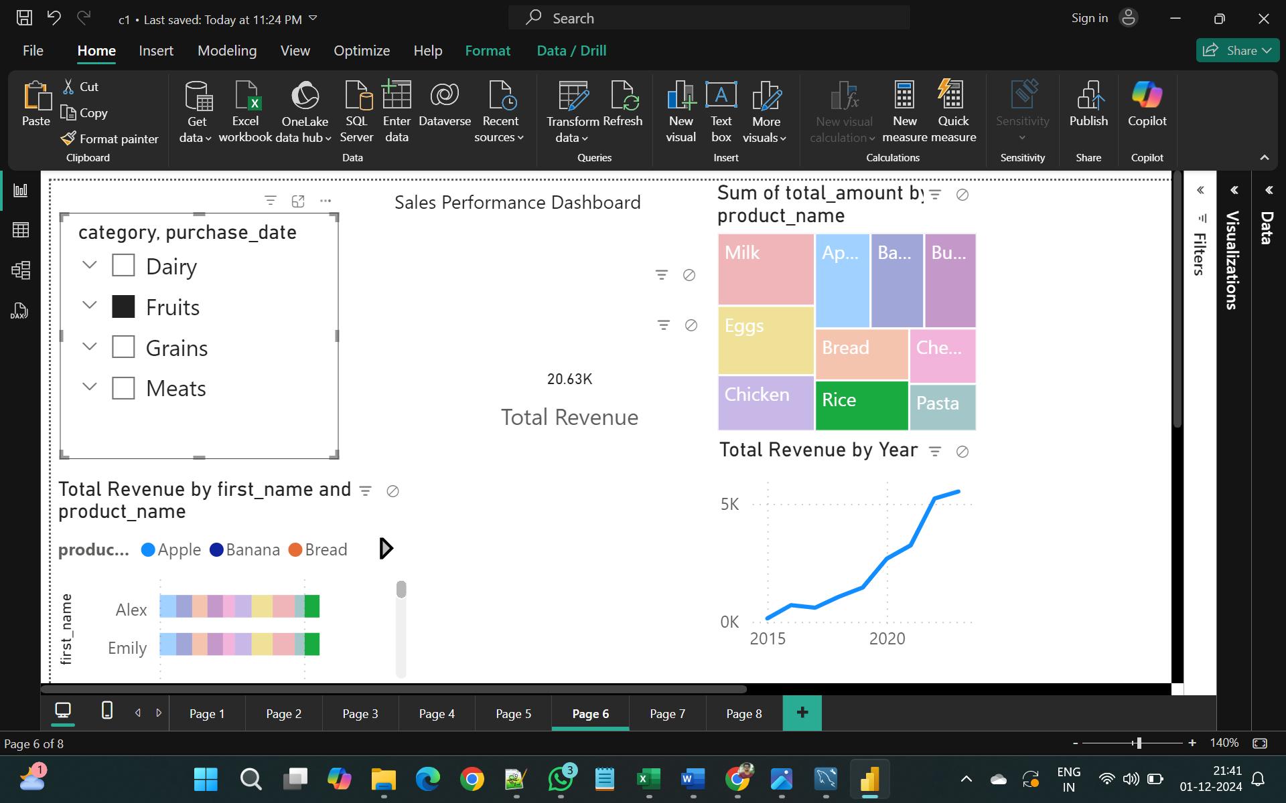

**Project Outcomes:**

The analysis yielded several significant insights that can guide the e-commerce platform's strategic decisions:

1. Gender Distribution of Purchases

- Analysis revealed a clear gender distribution in purchasing behaviour, enabling targeted marketing efforts to better engage specific demographics.

2. Average Purchase Value

- The report highlighted the average purchase value per product category and customer segment, helping identify potentially underperforming areas that might benefit from promotional activities.

3. Revenue Growth Analysis

- Identified top-performing products and cities, revealing key areas for expansion and marketing focus.

- Provided insights into revenue growth trends, indicating a positive trajectory alongside identifiable seasonal fluctuations.

4. Customer Retention Metrics

- Metrics on repeat purchases and frequency of customer transactions were analysed to assess customer loyalty and retention strategies.

- Insights into customer churn rates were also generated, suggesting areas for improvement in customer engagement practices.

5. Power BI Dashboard

- A comprehensive Power BI dashboard was created, summarizing key performance metrics and allowing stakeholders to visualize trends and insights in real time.

- The dashboard serves as an interactive tool for ongoing monitoring and decision-making.

**Conclusion:**

The Customer Purchase Analytics project successfully achieved its objectives, providing valuable insights into customer purchasing behaviours on the e-commerce platform. The findings have significant implications for marketing strategies, customer retention initiatives, and inventory management. Future work could involve implementing A/B testing for marketing campaigns and further refining customer segmentation strategies based on the analysis conducted.

**Improvement Steps:**

Based on the insights generated, the following next steps are recommended:

- Implement targeted marketing campaigns focusing on high-value customer segments and top-performing products.

- Develop a customer loyalty program aimed at enhancing retention based on frequency analysis results.

- Regularly update the Power BI dashboard to reflect real-time data for continuous monitoring of key performance indicators.